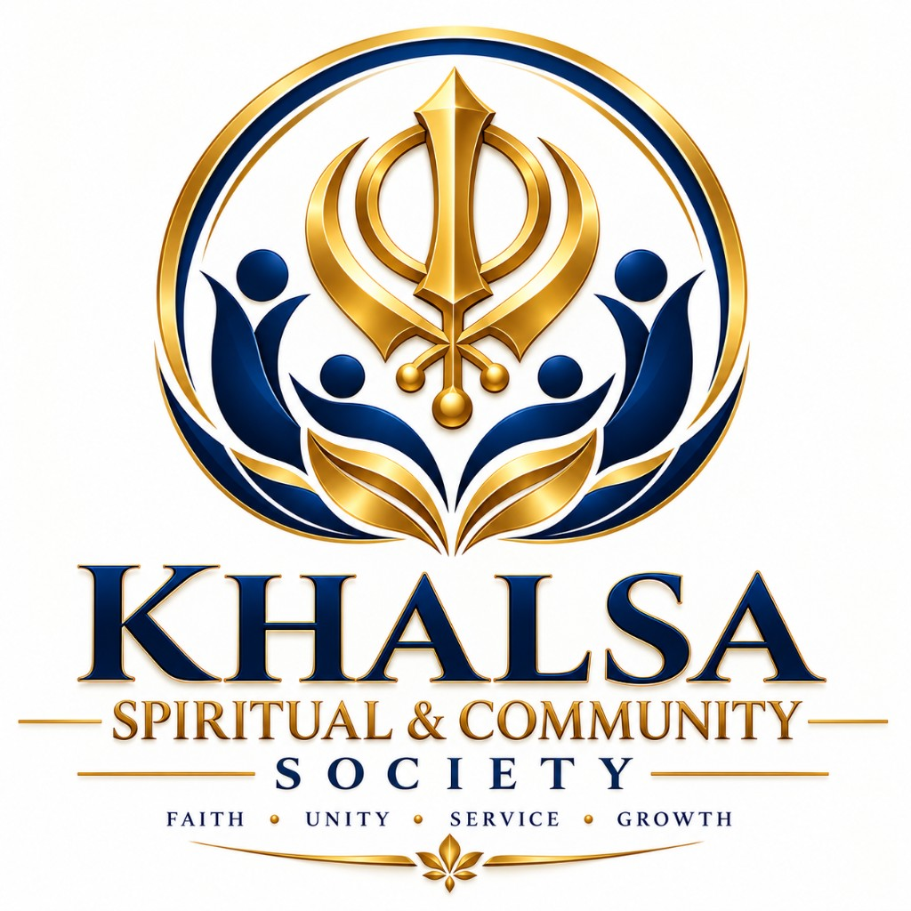 | KHALSA SPIRITUAL & COMMUNITY SOCIETY  17987412 Canada Society  Registered Non-Profit Religious Organization  Faith · Unity · Service · Growth
2250 Bovaird Drive E, Brampton, ON L6R 3J5 · Phone: 647-821-8723 · Email: khalsaspiritualcommunity@gmail.com

[Write your letter here]
Waheguru Ji Ka Khalsa, Waheguru Ji Ki Fateh
Nurturing spiritual growth through Gurbani · Sangat · Seva — open to all
17987412 Canada Society · Registered Non-Profit Religious Organization

